Hemanth Kumar B (192421263)
EX.NO:09 |E-BOOK MANAGEMENT SYSTEM
DATE: |

AIM:
To draw the diagrams [usecase, activity, sequence, collaboration, class, statechart, component, deployment, package ] for E-book management system.

SL.NO SOFTWARE REQUIREMENTS SPECIFICATION
1.0 Hardware Requirements
1.1 Software Requirements
1.2 Problem Analysis and Project Plan
1.3 Project description
1.4 Reference

1.0 HARDWARE REQUIREMENTS:
Intel Pentium Processor I3/I5
1.1 SOFTWARE REQUIREMENTS:
Rational rose / Argo UML

1.2 PROBLEM ANALYSIS AND PROJECT PLANNING
E-book Management System gives an idea about how books are maintained in the
particular websites. The books that are to be purchased, the books that are to be sold are maintained
here. . Further some additional details of the current books that is available in the store are also
given. E book Management System in this project is done in an authorized way. The password and user id has been set here.
1.3 PROJECT DESCRIPTION:
This software is designed to manage the books that were read through the internet. This
consists of the details of the e-book that were read by the user online. It will be controlled by the central system. This system act as a backup of all details together.
1.4 REFERENCES:
IEEE Software Requirement Specification format.

USE CASE DIAGRAM:
This diagram will contain the actors, use cases which are given below
Actors: user, e-book management
Use case: login ,search books, download ,pay for the books, logout .
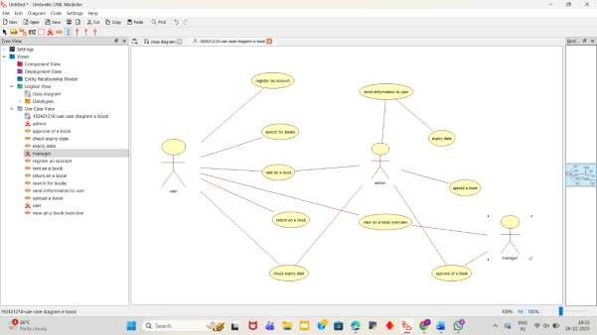
CLASS DIAGRAM:
This diagram consists of the following classes, attributes and their operations.
CLASSES ATTRIBUTES OPERATIONS
Internet Enter id, login, logout Surf book()
User Login, logout Surf book()
E-book management system verify user check availability()
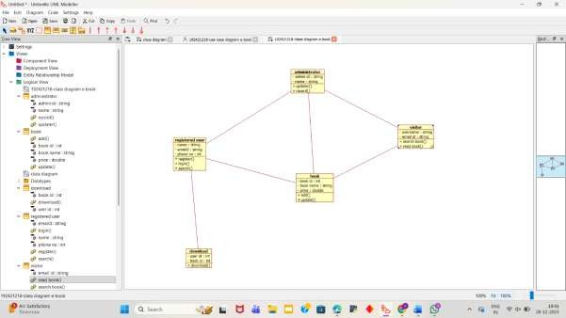
ACTIVITY DIAGRAM:
This diagram will have the activities as Start point ,End point, Decision boxes as given below:
Activities: Search for the e-book site,search for the book,download book Decision box: check availability
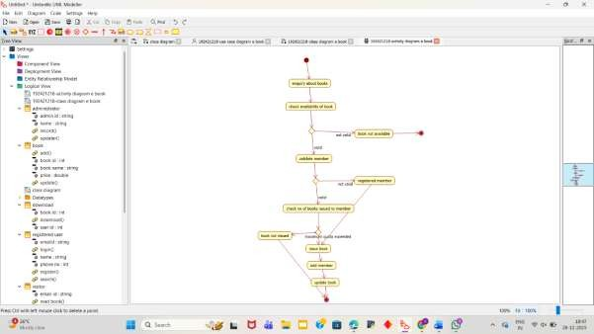

SEQUENCE DIAGRAM:
This diagram consists of the objects, messages and return messages.
Object: User ,E-book management ,Internet
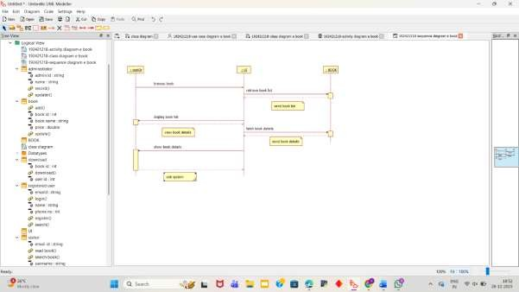

COLLABORATION DIAGRAM:
This diagram contains the objects and actors. This will be obtained by the completion of the sequence diagram and pressing the F5 key.
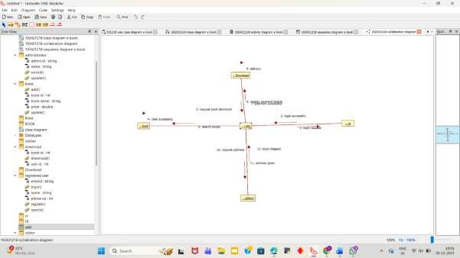
STATECHART DIAGRAM:
It is a technique to describe the behavior of the system. It describes all the possible states
that a particular object gets into the object oriented technique. State diagram are drawn for a single class to show to the lifetime behaviour of a single objects.
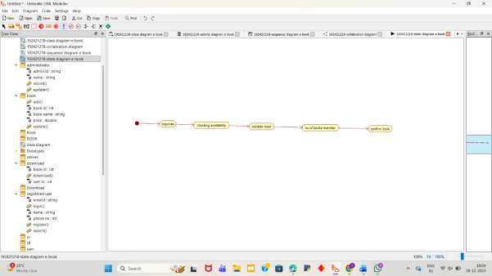
COMPONENT DIAGRAM:
The component diagram is represented by figure dependency and it is a graph of design of figure dependency. The component diagram's main purpose is to show the structural relationships between the components of a systems. It is represented by boxed figure.
Dependencies are represented by communication association.
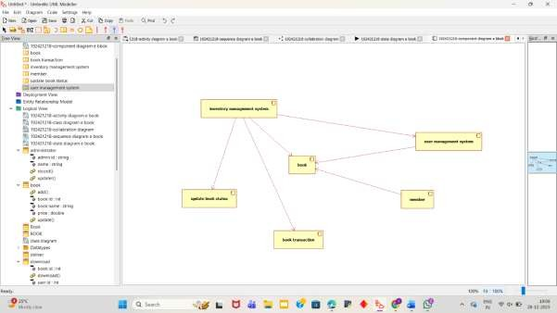

DEPLOYMENT DIAGRAM:
A deployment diagram in the unified modeling language serves to model the physical deployment of artifacts on deployment targets. Deployment diagrams show "the allocation of artifacts to nodes according to the Deployments defined between them. It is represented by 3- dimentional box. Dependencies are represented by communication association
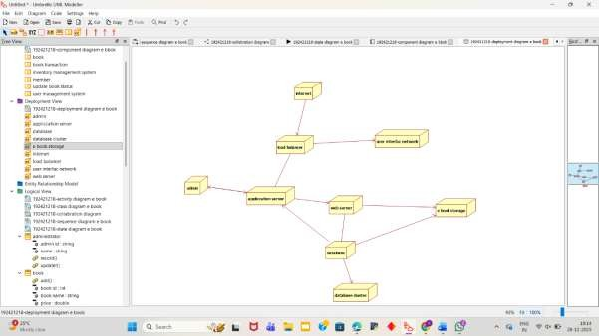

PACKAGE DIAGRAM:

A package diagram in unified modeling language that depicts the dependencies between the packages that make up a model. A Package Diagram (PD) shows a grouping of
elements in the OO model, and is a Cradle extension to UML. PDs can be used to show groups of
classes in Class Diagrams (CDs), groups of components or processes in Component Diagrams
(CPDs), or groups of processors in Deployment Diagrams (DPDs). There are three types of layer. They are o User interface layer o Domain layer o Technical services layer
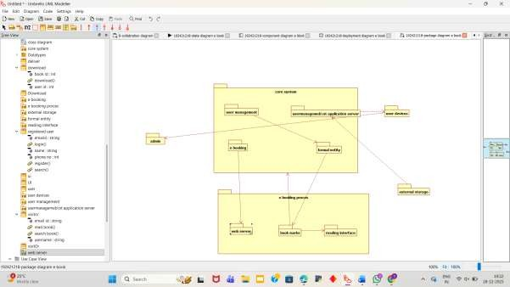

RESULT:
Thus the draw the diagrams [usecase, activity, sequence, collaboration, class, statechart, component, deployment, package ] for E-book management system.

